Removing Records with Missing Values

Definition
# Source: AI Source: Provided by: [Data Path: Persons Table -> ID Column: 1, Name_En Column: Motasem Essam] -> From: [Chatgpt (GPT‑5 Mini)] on [12/10/2025]
Removing Records with Missing Values is a method used in data cleaning where rows that contain missing or incomplete data are deleted from the dataset.
- This method is applied when the missing data cannot be reliably filled or estimated.
- It helps ensure that the remaining dataset contains complete and reliable information.

Key idea:
# Source: AI Source: Provided by: [Data Path: Persons Table -> ID Column: 1, Name_En Column: Motasem Essam] -> From: [Chatgpt (GPT‑5 Mini)] on [12/10/2025]
It is like discarding incomplete forms so that only fully filled forms are used for analysis.

Characteristics
# Source: AI Source: Provided by: [Data Path: Persons Table -> ID Column: 1, Name_En Column: Motasem Essam] -> From: [Chatgpt (GPT‑5 Mini)] on [12/10/2025]
- Removes rows that contain missing or null values
- Helps maintain data quality and consistency
- Simple and easy to implement
- Often used when the number of missing records is small
- Ensures analysis is performed only on complete data

Example
# Source: AI Source: Provided by: [Data Path: Persons Table -> ID Column: 1, Name_En Column: Motasem Essam] -> From: [Chatgpt (GPT‑5 Mini)] on [12/10/2025]
Original dataset:
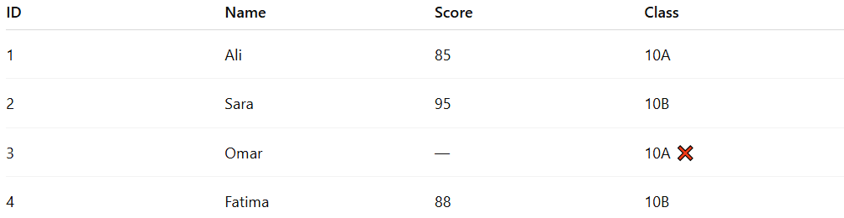
ID | Name | Score | Class
1 | Ali | 85 | 10A
2 | Sara | 95 | 10B
3 | Omar | — | 10A ❌
4 | Fatima | 88 | 10B
Record 3 has a missing score.
After removing the record with missing data:
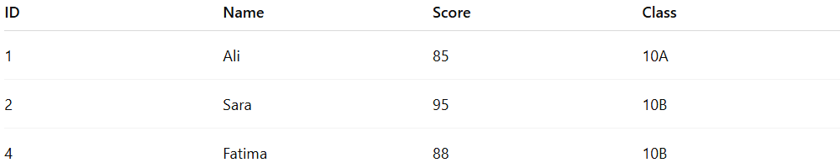
ID | Name | Score | Class
1 | Ali | 85 | 10A
2 | Sara | 95 | 10B
4 | Fatima | 88 | 10B
Now the dataset contains only complete records.

Example Section
# Source: AI Source: Provided by: [Data Path: Persons Table -> ID Column: 1, Name_En Column: Motasem Essam] -> From: [Chatgpt (GPT‑5 Mini)] on [12/10/2025]
A teacher is analyzing student scores but one student’s score is missing.
Before cleaning:
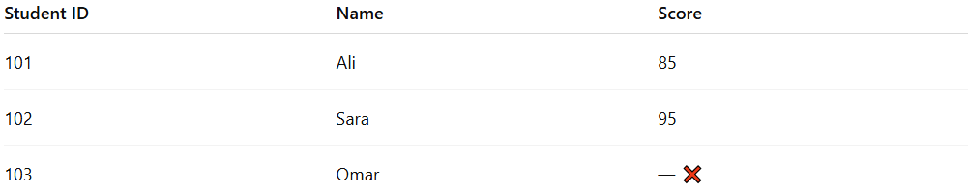
Student ID | Name | Score
101 | Ali | 85
102 | Sara | 95
103 | Omar | — ❌
Cleaning process:
- The teacher removes the record with the missing score.
After cleaning:
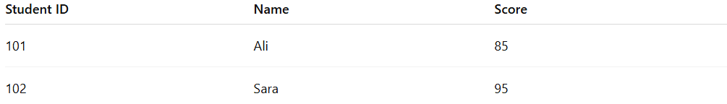
Student ID | Name | Score
101 | Ali | 85
102 | Sara | 95
This ensures that all remaining records contain complete data for analysis.

Advantages
# Source: AI Source: Provided by: [Data Path: Persons Table -> ID Column: 1, Name_En Column: Motasem Essam] -> From: [Chatgpt (GPT‑5 Mini)] on [12/10/2025]
- Simple and easy to apply
- Ensures only complete and reliable data is used
- Prevents errors in calculations or analysis
- Improves overall data quality

Disadvantages
# Source: AI Source: Provided by: [Data Path: Persons Table -> ID Column: 1, Name_En Column: Motasem Essam] -> From: [Chatgpt (GPT‑5 Mini)] on [12/10/2025]
- May reduce the size of the dataset
- Important information may be lost if many records are removed
- Can bias results if missing data is not random
- Not suitable when a large portion of the dataset has missing values

